

Dove – Little White Book

Functional Specification

# Confidential Information

This document is submitted under strict commercial confidentiality and no part of it may be disclosed for any reason to any third party without prior written consent from authorised representatives of Golin.

# Document History

|  |  |  |
| --- | --- | --- |
| Date | Author | Comments |
| 17/5/17 | Davide Ranchetti | * Removing reference to the List functionality. * Removing references to the Directory page. * Updating wireframes following UX feedback. |
| 15/5/17 | Peter Kemp |  |
| 15/5/17 | Davide Ranchetti |  |

# Reviewers

|  |  |  |
| --- | --- | --- |
| Date | Name | Position |
| 15/5/17 | Jackie Walbank | Digital Director |

Table of Contents

Confidential Information 2

Document History 2

Reviewers 2

1 Overview 5

2 Business requirements 5

3 Wireframes & User Interface Design 5

4 Common Components 6

5 Pages 7

5.1 Home 7

5.2 Search results page 9

5.3 Profile 11

5.4 Add/Edit a Profile 13

6 Information Architecture 14

6.1 Site collection 14

6.2 Lists 14

6.3 Libraries 15

6.4 Content Types 16

6.5 Site Columns 16

7 Permissions 19

8 Solution Assets 20

8.1 Master pages 20

8.2 Page layouts 21

8.3 CSS 21

8.4 JavaScript 21

8.5 Frameworks and Libraries 22

8.6 Imagery 22

8.6.1 Image renditions 23

8.7 Fonts 23

9 Accessibility 23

10 Development 24

10.1 Code Control 24

11 Browser & Device Testing 24

12 Deployment 25

13 Training 25

14 Documentation 26

# Overview

The following document provides detailed functional and technical specifications for the development of the Dove Little White Book. The site will be built on SharePoint on Unilever’s Inside.Unilever Microsoft Office 365 tenancy.

The specifications and information in this document are limited to the technical implementation of the Dove Little White Book site and assume administrative knowledge of SharePoint Online and Office 365.

# Business requirements

The primary aim of the platform is to to provide an engaging database intranet site for the Dove production agencies. The site would be a database, housing information on all the agencies that work on the production of product assets for Dove.

# Wireframes & User Interface Design

Following a number of high level requirements gathering calls and meetings focused on ascertaining the correct user experience for the Dove Little White Book site, Golin produced a series of Axure wireframe prototypes. The aim of these wireframes is to depict the intended structure and functionality of the site. These mock-ups are available at the following URL:

<http://ux.architectclients.com/unilever/dove/lwb/no-lists/>

As per the requirements and to save on project costs the overall look and feel and general design components will be replicated from the Dove Casting site, previously developed by Golin:

<https://unilever.sharepoint.com/sites/dovecasting/>

# Common Components

In SharePoint, the common page components are held in a master page, a feature that enables the definition of a common structure and interface for the site, including headers, footers, style definitions, navigation bars etc. The master page will be shared by all of the publishing pages of the site and removes the need to duplicate shared elements.

Below is a mock-up of the overall master page and common components of the site:

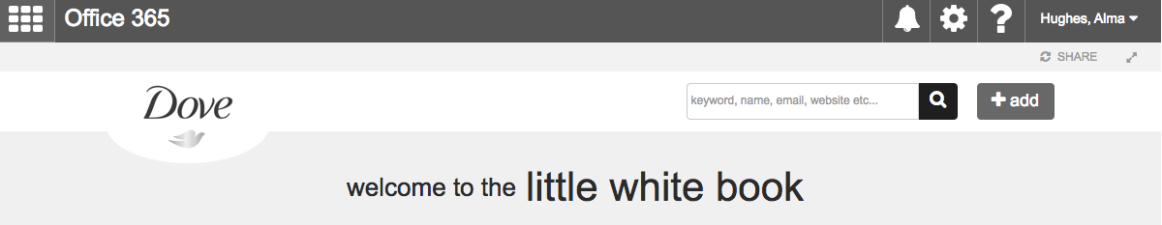

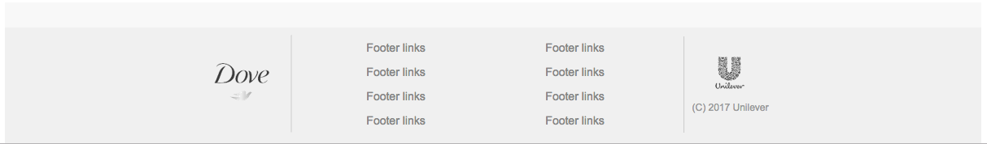

The numbered common components are outlined below:

1. **Suite Bar.** The code used to generate the SharePoint out-of-the-box suite bar is duplicated directly from SharePoint’s own seattle.master file, with no modifications.
2. **Logo.** The logo, which is situated at the top of every page in the site’s header, uses the out-of-the-box SharePoint SiteLogoImage control, with the link returning users to the Home page of the site.
3. **Search.** A text field that allows users to input keyword search terms. When the magnifying glass icon is clicked or the user hits return, they are redirected to the Search Results page where the results are filtered and sorted by the inputted search term.
4. **Add.** A button that redirects the user to the user to the Add a Profile page. This button will be held in a security trimming control that makes it only available to users with contribute permissions and above.
5. **Title.** This is pulled from the SharePoint site title.
6. **Dove footer logo.** A logo image held directly in the footer of the master page. Clicking on this logo take the user to the Dove external website (<http://www.dove.com/>), which is opened in a new tab.
7. **Footer Links.** This area hold a maximum of 8 links which are available to the user on every page. The items held within the footer links are managed from the Footer Links list.
8. **Unilever footer logo.** A logo image held directly in the footer of the master page. Clicking on this logo take the user to the Unilever external website (<https://www.unilever.co.uk/>), which is opened in a new tab.

# Pages

The following section outlines the main pages/views created as part of the Dove Little White Book site and the features and functionality of each.

## Home

The home page is the primary entry point for most users of the the Dove Little White Book site and provides quick access to the key areas of the site.

The page, which is set as the home page of the site collection, will be created from a single publishing page and use a series of Content Editor Web Parts to render HTML templates that drive the page content.

The following annotated image shows the design for this page:

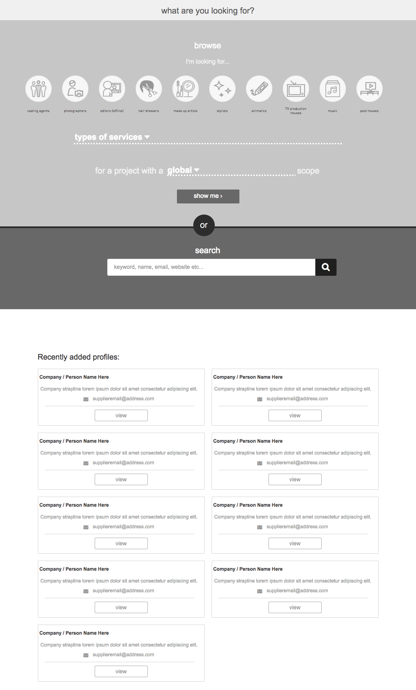

The numbered components are outlined below:

1. **Strapline.** An area that displays a description of the Dove Little White Book site. This is driven from the Strapline site column from the page Content Type.
2. **Categories.** A listing of icons for each of the Categories that the user can select to refine the profile directory. These Categories are driven by the Categories list that defines the title and icon for that Category. When a Category icon is selected the title for that Category is added to the field below.
3. **Scope.** An area where the user can refine the profile directory. From here the user can click on the field to define whether the profile should be global, regional or local. If the user selects regional or local, they are then presented with a list of options from the Regional or Local site columns.
4. **Show button.** Redirects the user to the search results page, showing the results accordingly to the scope selected.
5. **Search bar.** A text field that allows users to input keyword search terms. When the magnifying glass icon is clicked or the user hits return, they are redirected to the Search Results page where the results are filtered and sorted by the inputted search term.
6. **Recently Added Profiles.** Shows the eight most recent profiles added to the directory. Each item will show the company/person name, a strapline and an email address. The “view” button redirects the profile page.

## Search results page

The search results page is where the user can browse the complete list of the available profiles.

The page will be created from a single publishing page and use a series of Content Editor Web Parts to render HTML templates that drive the page content.

The following annotated image shows the design for this page:

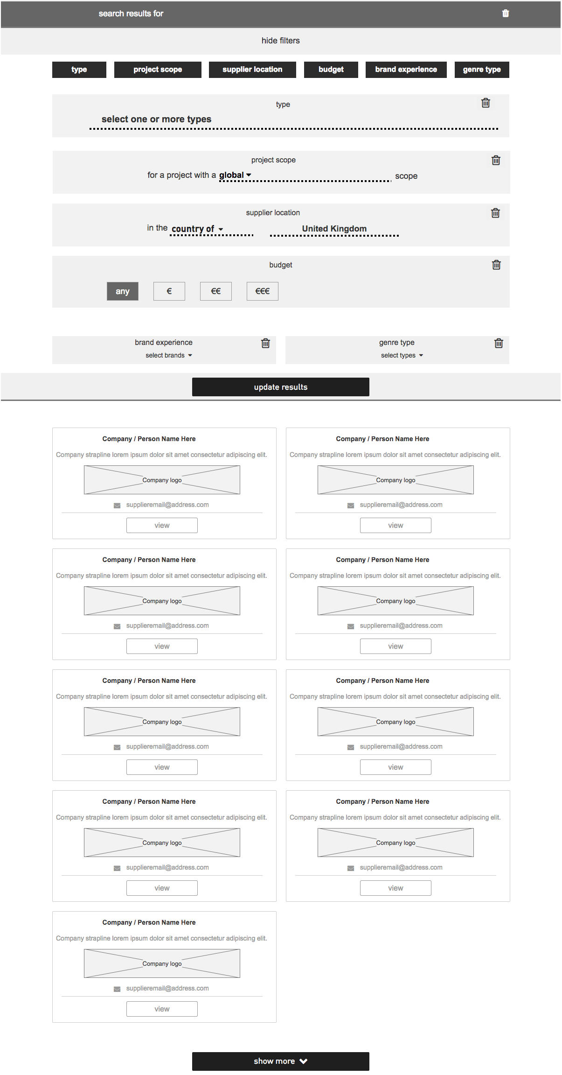

The numbered components are outlined below:

1. **Strapline.** An area that displays the terms used for the search.
2. **Filtering options.** A list of options to narrow down the results. When the user clicks on an option, a new section is added to the filtering panel.
3. **Type.** Allows the user to filter by agencies/people categories. These options are held in the Categories list.
4. **Scope.** An area where the user can refine the profiles. From here the user can click on the field to define whether the profile should be global, regional or local. If the user selects regional or local, they are then presented with a list of options from the Regional or Local site columns.
5. **Supplier location.** From here the user can define the location of the supplier, choosing from a list of clusters, countries or cities. These options are defined in the three site columns: Cluster, Country, City.
6. **Budget.** From here the user can define the budget of the project, choosing from four different values (any, €, €€, €€€). Each value is presented with a brief description. These values will be pulled from the Budget list.
7. **Brand experience.** From here the user can select the brand experience of the project. The options are pulled from the Brand Experience site column.
8. **Genre type.** From here the user can select the genre type of the project. The options are pulled from the Genre Type site column.
9. **Update results.** A button that allows the user to update the results accordingly to their filter selections.
10. **Listing.** List of the agencies/people available.Each item will show the company/person name, a strapline and an email address. The “view” button redirects the company/person page.

## Profile

The Profile page presents all the required information for an agency on a single page.

The Agency Profile page will be created from a single SharePoint publishing page. The content of the page will be generated from items in the Agencies list and rendered on the page via the APIs and a URL parameter.

The following annotated image shows the design for this page:

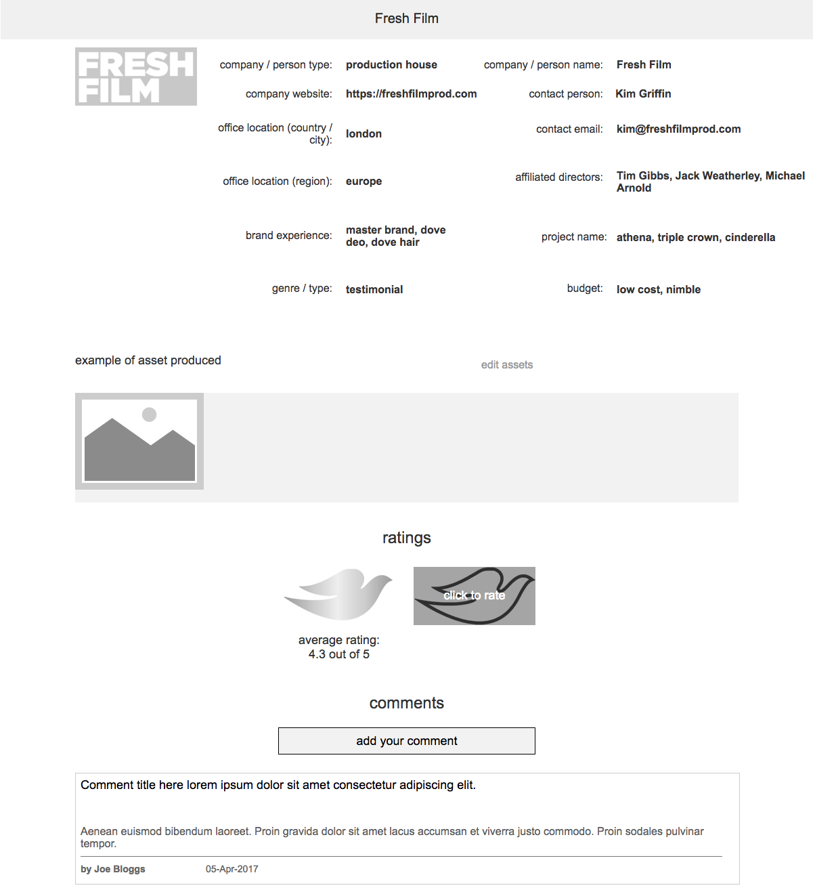

The numbered components are outlined below:

1. **Title.** An area that displays the profile title.
2. **Edit Agency Profile.** A link to edit the content of the Agency page. It will only be visible to users with contribute permissions and above.
3. **Profile photo and name.** An area that displays the chosen profile photo with the name of the Agency overlaid. The dimensions and size of this image will be fixed using a SharePoint image rendition. The image will be held in the Agency Images library.
4. **Agency** **information.** A list of information on the Agency all driven from fields in the Agencies list.
5. **Assets.** An area that displays a maximum of five assets, which are stored in the Agency Assets library. An image rendition will be used for these images that will format the width of the image to 230px.
6. **Ratings.** An area that displays the average rating for the agency. This information is held in the Profiles list, using the SharePoint out-of-the-box rating functionality.
7. **Click to rate.** Clicking on the “Click to rate” button, it’s possible to rate the agency with a score from 1 to 5.
8. **Add your comment.** Clicking on “add your comment” will allow the user to create a new comment specifying title and body.
9. **Comments list.** List of comments for the agency. Each comment will display a title, the body, the author’s name and the publishing date.

## Add/Edit a Profile

The Add/Edit Profile page presents a form to add a new agency on a single page.

The Add a Profile page will be created from a single SharePoint publishing page. The content submitted will be stored as a single list item in the Profiles list.

The following annotated image shows the design for this page:

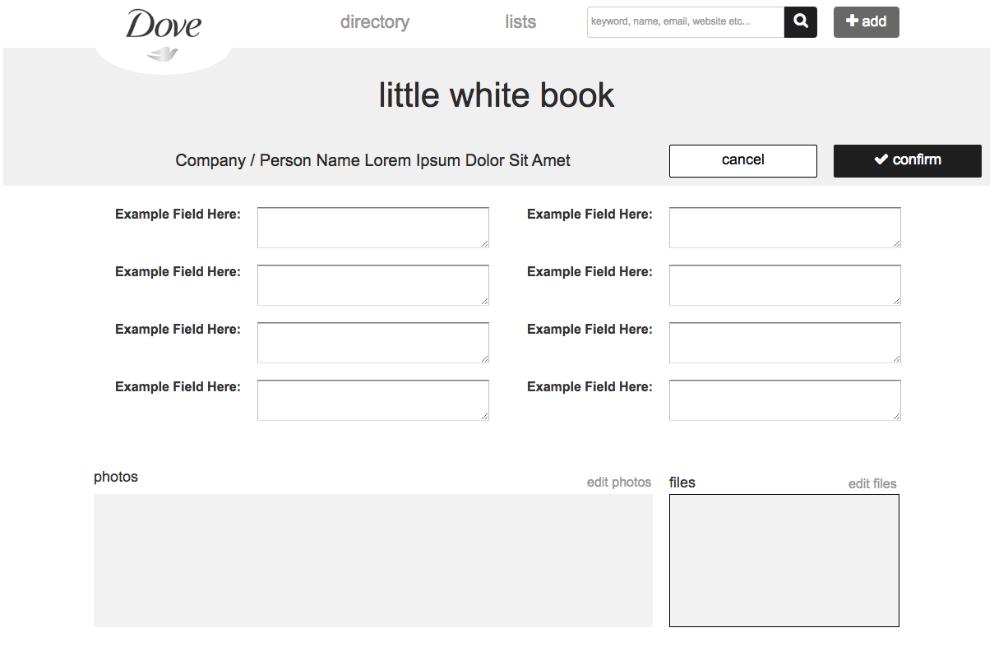

The numbered components are outlined below:

1. **Title.** The title of the agency/person that is being created/modified.
2. **Fields.** The fields that describe the agency/person.
3. **Photos.** An area that displays a maximum of five images, which are stored in the Agency Images library. An image rendition will be used for these images that will format the width of the image to 230px.
4. **File.** It’s possible to add a single file to be displayed in this area.
5. **Confirm.** This button allows the user to save the new item or update the profile that was being modified.This information is held in the Profiles list.

# Information Architecture

The following section provides detailed information on the information architecture for the site. This includes the following topics:

* Overall site structure
* Detail on the lists and libraries used as part of the solution
* Listings of required content types and site columns

## Site collection

The Dove Little White Book site will be built entirely on the top-level site of a single site collection. The lists and libraries outlined in the following sections will all be held in the top-level site.

## Lists

The following section outlines the main lists that sit within this site.

|  |  |
| --- | --- |
| Name | Description |
| Header Links | Used to define and manage the links held in the Header links section. |
| Footer Links | Used to define and manage the links held in the Footer links section. |
| Profiles | Used to hold the information of each Company / Person. The information held in this list is rendered on the Profile page via the API and URL parameter. |
| Categories | Used to hold the information of each agency category, such as the title and the icon. The information held in this list is rendered on the homepage via the API and URL parameter. |
| Budget | Used to hold the information of each budget value. |
| Comments | A list used to hold the Comments that users can input against each profile. |

## Libraries

The following section outlines the main libraries that sit within this site.

|  |  |
| --- | --- |
| Name | Description |
| Pages | The Pages library, a feature of the Publishing Portal site collection, will hold all Publishing pages for the site. |
| Agency Additional Info | A Document Library used to hold all files used for the Additional Info section on the Agency page. The files in this library are associated with an Agency in the item in Agencies list and rendered on the Agency page via the API. |
| Agency Assets | An Assets Library used to hold all the images video files used for the Agency page. The assets in this library are associated with an Agency in the item in Agencies list and rendered on the Agency page via the API. |

## Content Types

Content types enable administrators to organise, manage, and handle content in a consistent way across the sites. Defining content types for specific kinds of documents or information products ensures that each group of content is managed in a consistent way.

The following section outlines the main content types that will be created as part of this project.

|  |  |
| --- | --- |
| Name | Parent Type |
| Header Links | Item |
| Footer Links | Item |
| Profiles | Item |
| Category | Item |
| Budget | Item |
| Comments | Item |

**NOTE** This table does not outline the out-of-the-box Content Types that may be used as part of this project.

## Site Columns

A site column is a reusable column definition, or template, that can be assigned to multiple lists and libraries across SharePoint sites. Site columns are useful when establishing consistent settings across lists and libraries.

The following section outlines the main site columns that will be created as part of this project.

|  |  |  |
| --- | --- | --- |
| Name | Type | Comments |
| Title | Single line of Text |  |
| Order | Number |  |
| Description | Single line of Text |  |
| URL | Hyperlink |  |
| Name | Single line of Text |  |
| Image | Publishing Image |  |
| Profile photo | Hyperlink or Picture | Set to Picture |
| Company/Person type | Lookup (Categories list) | Animatics, Casting agents, TV production houses, Digital content production houses, Photographers, Music, Editors (Offline), Post Houses (Online), Hair dressers, Make up artist, Stylist |
| Office Location (Region) | Checkbox | All current nationalities |
| Office Location (Country) | Checkbox |  |
| Office Location (City) | Date and Time | Set to date only. |
| Company Website | Hyperlink or Picture | Set to Hyperlink |
| Contact Person | Single line of Text |  |
| Contact Email | Single line of Text |  |
| Affiliated Directors | Single line of Text |  |
| Brand experience | Checkbox | Masterbrand, Dove Deo, Dove Hair, Dove Skincare, Dove Baby, Dove Mens |
| Project Name Experience | Single line of Text |  |
| Genre/type | Checkbox | Pack, Texture, Hair, Skin, Storytelling, Testimonial, Product |
| Budget | Lookup (Budget list) | € - low cost, nimble  €€ - good, solid, middle weight  €€€ - high end, traditional, above pay scale crew |
| Agency | Lookup (Profiles list) |  |

**NOTE** This table does not outline the out-of-the-box Site Columns that may be used as part of this project.

The following table maps the Site Columns to the Content Types they are used in.

* R = Required
* O = Optional

|  |  |  |  |  |  |  |
| --- | --- | --- | --- | --- | --- | --- |
|  | Header Links | Footer Links | Profiles | Category | Budget | Comments |
| Title | R | R | R | R | R | R |
| Order |  |  |  |  | R |  |
| Description |  |  |  |  | R | R |
| Agency |  |  |  |  |  | R |
| URL | O | O |  | O |  |  |
| Name |  |  | R |  |  |  |
| Image |  |  | O | R |  |  |
| Profile photo |  |  | O |  |  |  |
| Company/Person type |  |  | O |  |  |  |
| Office Location (Region) |  |  | O |  |  |  |
| Office Location (Country) |  |  | O |  |  |  |
| Office Location (City) |  |  | O |  |  |  |
| Company Website |  |  | O |  |  |  |
| Contact Person |  |  | O |  |  |  |
| Contact Email |  |  | O |  |  |  |
| Affiliated Directors |  |  | O |  |  |  |
| Brand experience |  |  | O |  |  |  |
| Brand experience other |  |  | O |  |  |  |
| Project Name Experience |  |  | O |  |  |  |
| Genre/type |  |  | O |  |  |  |
| Genre/type other |  |  | O |  |  |  |
| Budget |  |  | O |  |  |  |

# Permissions

The following section outlines the permission levels and access requirements for the Dove Little White Book site.

The following table outlines the permission groups and permissions levels that will be created as part of this requirement. These groups and permission levels will be applied to all aspects of the Little White Book site.

|  |  |
| --- | --- |
| Name | Permission Level |
| Dove Little White Book Owners | Full Control |
| Dove Little White Book Members | Contribute |
| Dove Little White Book Visitors | View Only |

# Solution Assets

The following section outlines the custom solution assets (master page, CSS, JavaScript etc.) which have been created as part of the project requirement.

Where possible we opt for configuration over development and minimise customisation to any SharePoint functionality. By provisioning supplementary page layouts, and well documented JavaScript, HTML and CSS, we ensure as far as possible that our development is extendible, reusable and future-proofed against Office 365 updates.

To manage or amend the assets outlined in this section requires SharePoint development expertise, Front-End development expertise and expertise in the code and frameworks referenced in this section.

## Master pages

The global elements of the site will be contained in the master page. The master page is a feature that enables the ability to define common structure and interface the website, including headers, footers, style definitions, navigation bars etc. The master page will be shared by all of the pages in the site and removes need to duplicate shared elements.

The Dove Little White Book site will make use of a single custom master page file. The master page will be created as an HTML file which using the SharePoint Design Manager is automatically converted into an ASPX MASTER file. Both files are held in the Master Page Gallery.

The custom master page will be set as a site master page which is used by all publishing pages - the pages that non-administrative visitors will see. The SharePoint out-of-the-box seattle master page will be used as the System Master Page, which is used by administrative pages, lists and libraries views.

## Page layouts

Page layouts in SharePoint are files which help to predefine the overall arrangement of elements (content) within a publishing page.

The following table outlines the custom page layouts required as part of the solution:

|  |  |
| --- | --- |
| Name | Description |
| Dove Little White Book | Used for every publishing page used within the Dove Little White Book site. |

## CSS

The Style Library site will utilise CSS and CSS3 specifications to handle the presentation of the HTML and content such as setting the layout, fonts and colours.

The CSS will be created locally using the CSS pre-processor Sass and compiled down to standard CSS before being uploaded to the site. All CSS will be contained within a single file and is stored in Style Library.

## JavaScript

All JavaScript will be created locally using the module bundler webpack 1.14.0 (<https://webpack.github.io/>) to concatenate the files into a single minified JavaScript file. The JavaScript file will be stored in the Style Library.

## Frameworks and Libraries

The following JavaScript and CSS frameworks that are used within the solution:

|  |  |  |
| --- | --- | --- |
| Name | Description | URL |
| React | A JavaScript library for building user interfaces | <https://facebook.github.io/react/> |
| jQuery 3.1.1 | HTML document traversal and manipulation, event handling, animation, and Ajax | <https://jquery.org/license/> |
| PnP JS Core | Library to help simplifying common operations within SharePoint and the SharePoint Framework. | <https://github.com/SharePoint/PnP-JS-Core> |
| Moment.js | Full featured date library for parsing, validating, manipulating, and formatting dates. | <http://momentjs.com/> |
| Office UI Fabric | The official front-end framework for building experiences that fit seamlessly into Office and Office 365. | <http://dev.office.com/fabric> |

## Imagery

All imagery used as part of the solution will be optimised for the web and stored in the Style Library.

Golin will be providing the image assets necessary for the development of site design as per the approved wireframes and designs.

**NOTE** Beyond the imagery used within the approved designs, sourcing and licensing for additional imagery is excluded.

### Image renditions

An image rendition defines the dimensions that are used to display images in a SharePoint site. The following image renditions will be defined for this project:

|  |  |  |
| --- | --- | --- |
| Name | Width | Height |
| Agency Profile Photo | 200px |  |
| Agency Photos | 230px |  |

## Fonts

A number of custom web fonts will be used as part of the site design, as well as additional font files. All font files will be stored in the Style Library.

# Accessibility

SharePoint Online provides a number of accessibility features out-of-the-box which helps to ensure that the sites are accessible to people with disabilities as outlined in the following article:

<https://support.office.com/en-gb/article/Accessibility-features-in-SharePoint-products-f291404a-dc7e-44de-a31f-d81b3099c2b9>

Where possible we will ensure that the solution will remain in line with SharePoint’s own out-of-the-box Accessibility standards.

# Development

Development of the Dove Little White Book site will be completed on a SharePoint Publishing site. The site collection will be hosted on Unilever’s development tenancy and was provided to Golin by the Unilever Collaboration Service/SharePoint Delivery team.

## Code Control

During the development phase, the project will be held within a private Github.com repository. Git, which is a distributed revision control and source code management system, will be used by Golin to manage all development for the site.

As requested by the Unilever Collaboration Service/SharePoint Delivery team, during the development phase the code will periodically pushed to a Dove Little White Book site repository on Unilever’s Visual Studio Team Services (VSTS):

<https://cstfsunilever.visualstudio.com/Team%20Golin/>

# Browser & Device Testing

Where possible the site will be built in accordance with the Microsoft SharePoint browser support plans:

* <https://technet.microsoft.com/en-GB/library/cc263526.aspx>
* <https://products.office.com/en-us/office-system-requirements>

*“SharePoint 2013 supports several commonly used web browsers, such as Internet Explorer, Google Chrome, Mozilla Firefox and Apple Safari. However, certain web browsers could cause some SharePoint 2013 functionality to be downgraded, limited, or available only through alternative steps.”*

The site will be tested against the browsers and devices outlined in the following table:

|  |  |
| --- | --- |
| Browser | Device |
| Internet Explorer 11+ | Desktop/laptop |
| Chrome (latest version) | Desktop/laptop |
| Safari (latest version) | iPad, iPhone 6+ |

# Deployment

Following completion of the development phase and after Golin’s internal testing phase, the solution, which includes all assets, configurations, lists, libraries, content types etc. will need to be deployed to the following site collections:

* Dev Int: TBC
* QA: TBC
* Production: TBC

All site collections have been pre-setup by the Unilever Collaboration Service/SharePoint Delivery team.

To facilitate moving the solution between these site collections, deployment and configuration of assets and features will be handled by scripts created in Microsoft PowerShell, an automation and scripting platform for Windows built on top of the object-oriented power of the .NET Framework.

The deployments to Dev Int, QA and Production will be completed by the Unilever Collaboration Service/SharePoint Delivery team, therefore Golin will provide a brief deployment guide, that outlines the required deployment steps and manual configurations.

# Training

As part of the of the delivery of the project and upon completion of the development of the site, Golin will orchestrate a single two-hour Site Administrators training session.

As Unilever will have been given visibility during the development phase, it is anticipated that the training agenda, supplemented by the supporting handover documentation, will focus only on the key tasks for the administration of the site.

# Documentation

Golin will supply an updated version of this document outlining all the customisations and configurations made as part of the site development. As mentioned in the section on Deployment, this document will include a brief deployment guide, that outlines the required deployment steps and manual configurations.

**NOTE** All documentation will assume administrator knowledge of SharePoint and Office 365.